|  |  |
| --- | --- |
| **420-PHN-ID – Digital Photography** | **FINAL EXAM (25 %)** |
| **NAME :** ______________________________  Circle your answer : | **MARK : _______ /50** |
| **Question 1** | /2 |

In order to have a greater depth of field, you should prefer :

1. A bigger aperture (e.g. f/2.8)
2. A smaller aperture (e.g. f/22)
3. Automatic setting
4. Macro mode

# Question 2 /2

In order to have a greater depth of field, you should prefer :

1. A zoom
2. A shorter focal length
3. A longer focal length
4. A normal focal length

# Question 3 /3

Let’s suppose that the setting for a perfect picture are: ISO 100, f5.6, 1/250.

In order to have a greater depth of field, what should you do?

1. Close the aperture (e.g. to f16)
2. Choose a higher ISO factor (e.g. ISO 400)
3. Choose a higher shutter speed (e.g. 1/500)
4. Choose a lower shutter speed and close aperture
5. Choose a higher ISO factor and close aperture
6. B and C
7. D and E
8. None of the above

# Question 4 /2

White balance :

1. Produces a better resolution
2. Insure the colors are correct
3. Has a temperature of 5 400 Kelvin
4. All of the above
5. None of the above

# Question 5 /5

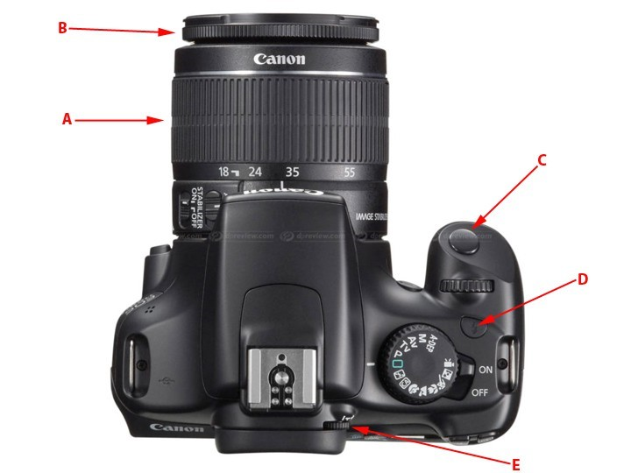

According to the above image, identify the following parts :

(Write the letter corresponding to you answer)

|  |  |  |
| --- | --- | --- |
| 1. | Shutter | **_____C_____** |
| 2. | Focal adjustment | **____A______** |
| 3. | Dioptry adjustment | **____E______** |
| 4. | Flash release button | **______D____** |
| 5. | Focus adjustment | **_______A___** |

# Question 6 /6

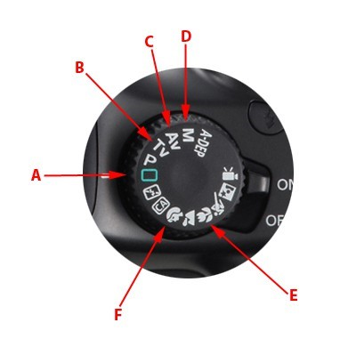

According to the above image, identify the following presets :

(Write the letter corresponding to you answer)

|  |  |  |
| --- | --- | --- |
| 1. | Macro | **___E_______** |
| 2. | Aperture first | **___C_______** |
| 3. | Automatic | **____A______** |
| 4. | Manual | **___D_______** |
| 5. | Shutter (Time) first | **___B_______** |
| 6. | Portrait | **___F_______** |

# Question 7 /6

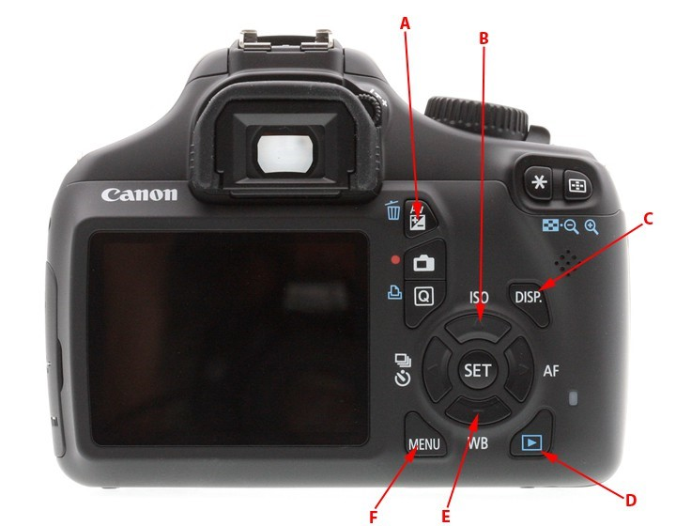

According to the above image, identify the following functions/settings :

(Write the letter corresponding to you answer)

|  |  |  |
| --- | --- | --- |
| 1. | Sensor (CMOS) sensitivity adjustment | **___B_______** |
| 2. | Review images stored on the memory card | **___D_______** |
| 3. | Aperture adjustment | **___A_______** |
| 4. | Shows current settings on screen | **___C_______** |
| 5. | Adjust the temperature of light | **____E______** |
| 6. | Complete camera settings | **____F______** |

# Question 8 /10

On this illustration of a set, position correctly (drawing the symbols) the lights in order to produce the typical 3 points lighting of a model.

main

Fill light

backlight



Main light *Fill light Back light*

*1000 watts 500 watts 2000 watts*

# Question 10 /7

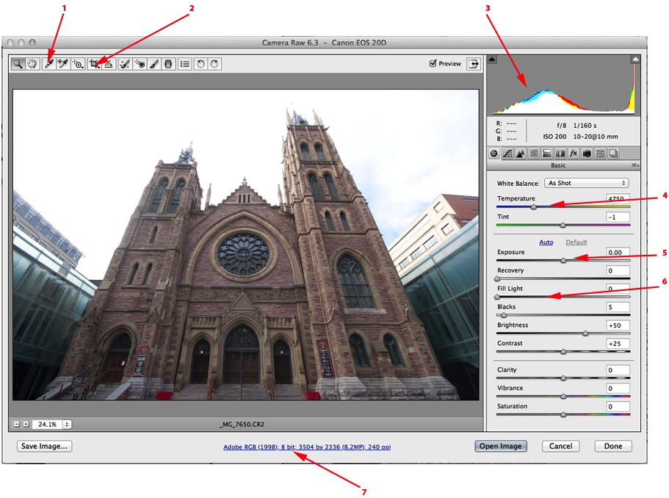

Identify the following camera raw adjustments :

(Write the corresponding numbers)

|  |  |
| --- | --- |
| Simulate fill light : | **___6_______** |
| Luminosity adjustment : | **____5_____** |
| Size, color mode and resolution adjustments : | **_____1_____** |
| White balance adjustment : | **____4______** |
| Crop tool : | **___2_______** |
| Tool showing the tonal composition of the image : | **_____7_____** |
| Tool used to easily adjust white balance : | **____3_____** |

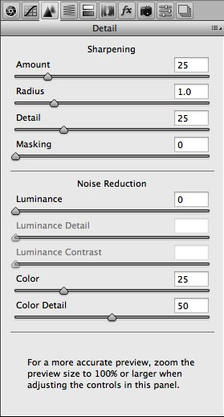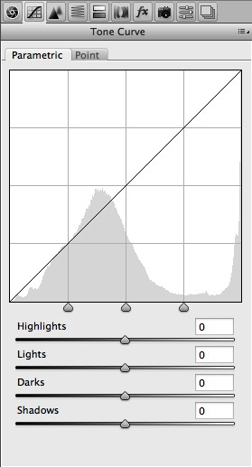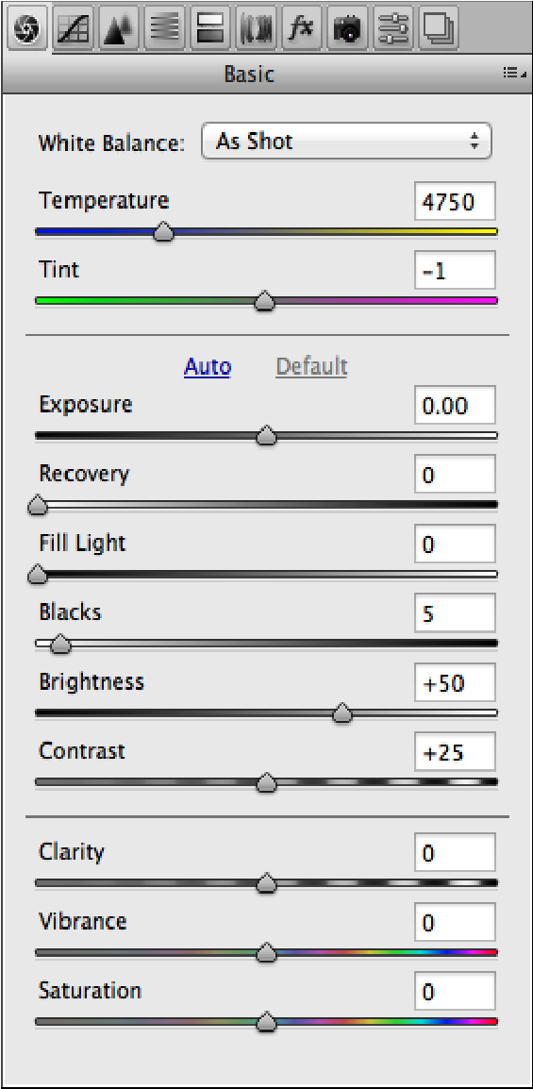

**A B C**

# Question 11 /4

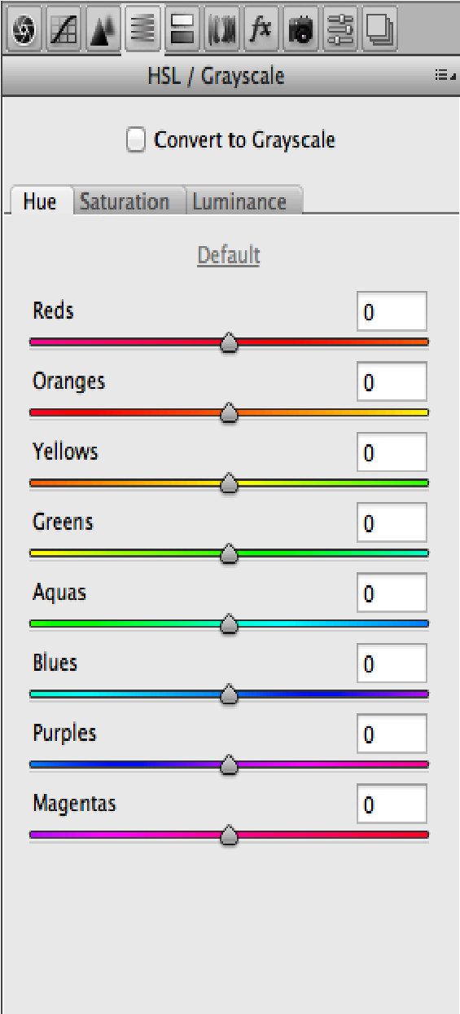

Identify the proper panels:

(Write the corresponding letter)

Panel used to correct a blurred image **_C_________** and to suppress noise:

Panel used to adjust the luminosity of different

tones of an image : **____A______**

Panel in which you can correct the color of the light : **___D_______**

Panel in which you can adjust the lightness,

the tint and the concentration of colors : **____B______**

**D**

# Question 12 /3

Identify the type (the genre) of photography (e.g. portrait, landscape, etc.) :

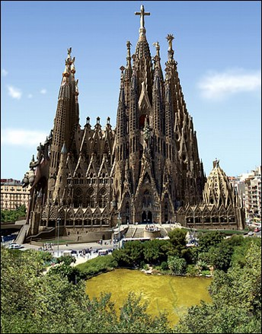 **__Landscape_________________________**

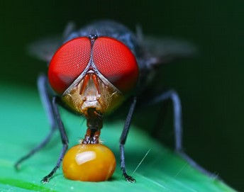 **______Potrait__________________________**

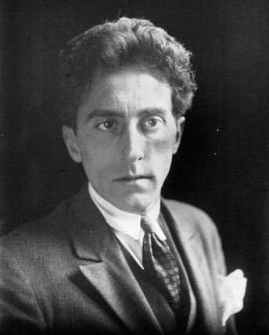 **_________Potrait_______________________**